**Database Application Programming**

**Project Status and Design Report**

|  |  |  |
| --- | --- | --- |
| **Topic:** | Milestone 8: Comment on and Rate a Blog Post | |
| **Date:** | *06/09/2019* | |
| **Revision:** | *1.0* | |
| **Team:** | 1. *Daniel Cutrara* | |
|  | |
|  | |
|  | |
| **Team Status:** | |  |  |  |  | | --- | --- | --- | --- | | **Task** | **Team**  **Member** | **Hours**  **Worked** | **Hours Remaining** | | *Create a user registration page for your blog.* | *Daniel* | *1* | *0* | | *In MySQL, build the necessary tables to store the information* | *Daniel* | *1* | *0* | | *In PHP, write the functions that will enable the capturing of user input and store in the database* | *Daniel* | *1* | *0* | | *Create a login page for your blog.* | *Daniel* | *2* | *0* | | *Create a new blog post* | *Daniel* | *2* | *0* | | *Capture the new post and store in the database* | *Daniel* | *2* | *0* | | *Implement a simple language filter* | *Daniel* | *2* | *0* | | *Create an Azure account and upload all files to your account* | *Daniel* | *2* | *0* | | *Interface for the blog administrator to categorize (tag) and remove posts.* | *Daniel* | *4* | *0* | | *Create the page that allows an authorized user to search for posts using multiple criteria.* | *Daniel* | *4* | *0* | | *Create the mechanism that allows an authorized user to reply (comment) on a post and rate it.* | *Daniel* | *5* | *0* | |  |  |  |  | |  |  |  |  | | |
| **GIT URL:** | <https://github.com/Dcutrara1/CST-126> | |
| **Hosting URL:** | <https://dan-blog.herokuapp.com/> | |
| **Peer Review:** | *Y/N* | We acknowledge that our team has reviewed this Report and we agree to the approach we are all taking. |

**Supporting Design Documentation**

**Install Instructions:**

*I have moved my application back to Heroku due to Azure trial ending.*

**General Technical Approach:**

*Admin Key to create admin user is "blog".*

*Admin User to test system is username:* [*cutrarads@gmail.com*](mailto:cutrarads@gmail.com) *password: test3*

**Key Technical Design Decisions:**

*Any final technical design decisions, such as framework decisions and so forth, should be documented here. This should list the technology/framework, its purpose in the design, and why it was chosen.*

**ER Diagram:**

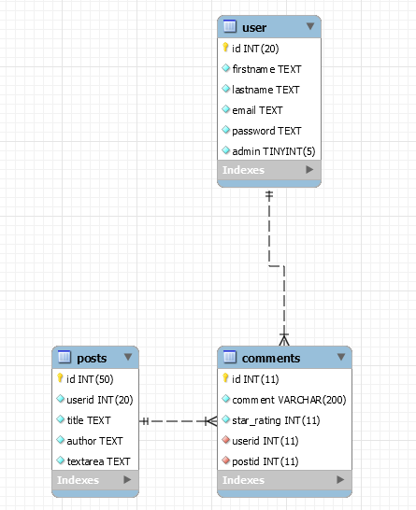

**DDL Scripts:**

<https://github.com/Dcutrara1/CST-126>

**Sitemap Diagram:**

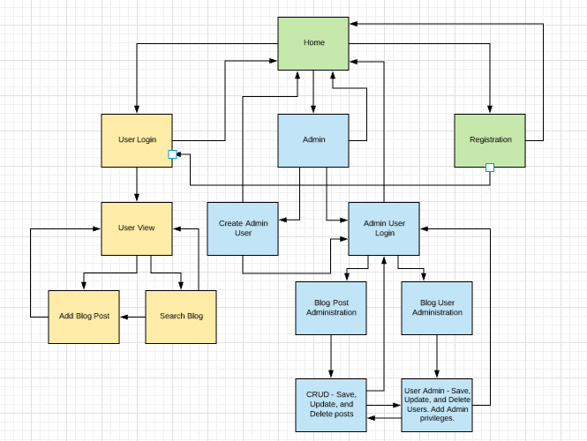

**User Interface Diagrams:**

*You should insert any wireframe drawings or white board concepts that were developed to support your application. If you have no supporting documentation, please explain the rationale for leaving this section as N/A.*

**Other Documentation:**

*You should insert any additional drawings, storyboards, white board pictures, project schedules, tasks lists, etc. that support your approach, design, and project. If you have no supporting documentation, please explain the rationale for leaving this section as N/A.*